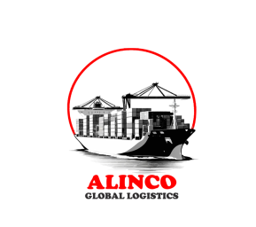

12, Mbanugo Street Ikate Surulere Lagos.

www.alincoglobalogistics.com

info@alincoglobalogistics.com

alinco4balo@yahoo.com

+234 707 751 1423

RC 1573438

ALINCO GLOBAL SOLUTION NIGERIA LIMITED

**ALINCO GLOBAL LOGISTICS**

**SOLUTION NIGERIA LIMITED**